*26th ICHST, Prague / Czech Republic, July 25-31, 2021*

Abstract

**THE FOUNDERS OF ROMANIAN BIOLOGICAL OCEANOGRAPHY -**

**EMIL RACOVITZA, IOAN BORCEA AND GRIGORE ANTIPA**

**Alexandru Ş. Bologa**

Academy of Romanian Scientists / Constanţa Branch, ROMANIA

E-mail: <[bologa1813@yahoo.ro](mailto:bologa1813@yahoo.ro)>

Over a century passed since the Romanian participation in the major oceanographic research cruise, on board *Belgica*, in the Antarctic waters (1897). The gradual development of marine sciences in Romania is due mainly to **Emil Racovitza** (1878-1947), **Ioan Borcea** (1879-1936), **Grigore Antipa** (1867-1944) and others, and to their institutional establishments such as the Marine Zoological Station at Agigea - Constantza (1926), the Bio-oceanographic Institute in Constanţa (1932), the National Museum of Natural History in Bucharest (1934) a.o. Other professors, researchers and museographers contributed significantly to the progress of biological oceanography. Witness stands also Romania's affiliation to many regional and international scientific organizations like the **International Commission for the Scientific Exploration of the Mediterranean Sea (CIESM)** from Monaco from its early beginning, UNESCO, the **International Ocean Institute** created by Professor Elisabeth Mann-Borgese in Malta etc. Romanian leading marine research and development institutes, namely the ***National Institute for Marine Research and Development „Grigore Antipa”*** in Constantza and the ***National Institute for Marine Geology and Geoecology***, respectively, must be mentioned, as well as new created marine environment devoted NGOs. They interacted with the activities of the **Black Sea Commission**, acting on the mandate of all six Black Sea coastal states which on April 21,1992 signed and shortly thereafter ratified the ***Convention on the Protection of the Black Sea Against Pollution***, the ***Commission on the Protection of the Black Sea Against Pollution*** (***Black Sea Commission***) of the *Convention and the* ***Black Sea Strategic Action Plan***.

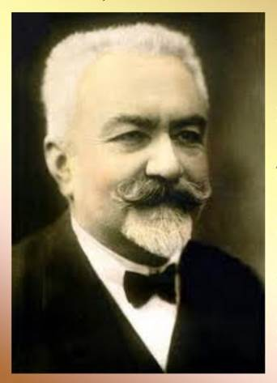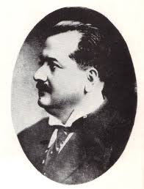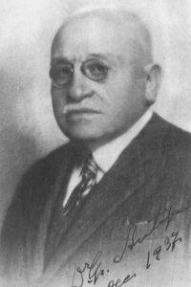

Emil Racovitza Ioan Borcea Grigore Antipa